'Total ЗТЭ+ДТЭ EQD2': 'c136',

'HRCTV 90 EQD2': 'c54',

'volume': 'c40',

'үе шат': 'c12',

'хавдрын үр дүн': 'c200',

'Химийн эмчилгээний давтамжийн тоо': 'c140'}

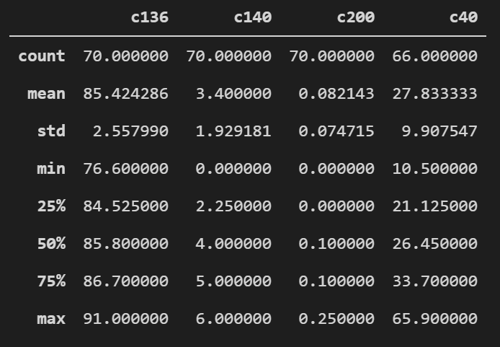

|  |  |  |  |  |  |  |  |  |
| --- | --- | --- | --- | --- | --- | --- | --- | --- |
| SUMMARY OUTPUT | Y=c136 | X=c40 |  |  |  |  |  |  |
|  |  |  |  |  |  |  |  |  |
| *Regression Statistics* | |  |  |  |  |  |  |  |
| Multiple R | 0.267031001 |  |  |  |  |  |  |  |
| R Square | 0.071305556 |  |  |  |  |  |  |  |
| Adjusted R Square | 0.056794705 |  |  |  |  |  |  |  |
| Standard Error | 2.549070196 |  |  |  |  |  |  |  |
| Observations | 66 |  |  |  |  |  |  |  |
|  |  |  |  |  |  |  |  |  |
| ANOVA |  |  |  |  |  |  |  |  |
|  | *df* | *SS* | *MS* | *F* | *Significance F* |  |  |  |
| Regression | 1 | 31.92964467 | 31.92964467 | 4.913947305 | 0.030200937 |  |  |  |
| Residual | 64 | 415.8565674 | 6.497758866 |  |  |  |  |  |
| Total | 65 | 447.7862121 |  |  |  |  |  |  |
|  |  |  |  |  |  |  |  |  |
|  | *Coefficients* | *Standard Error* | *t Stat* | *P-value* | *Lower 95%* | *Upper 95%* | *Lower 95.0%* | *Upper 95.0%* |
| Intercept | 83.40527086 | 0.942018534 | 88.53888518 | 1.16693E-68 | 81.5233725 | 85.28716922 | 81.5233725 | 85.28716922 |
| c40 | 0.070741493 | 0.031912364 | 2.216742499 | 0.030200937 | 0.006989218 | 0.134493769 | 0.006989218 | 0.134493769 |

